

NVCG Treasurers Report

August 2024

1). **Membership Applications 2024 to date**

| Dr. Edmore Mushoriwa | State Veterinary KZN |
| --- | --- |
| Dr. Chris Collie | Bryanston Veterinary Hospital |
| Dr. Bevin Meyer | Private |
| Dr. Murray Hyslop | Parkmore Veterinary Clinic |
| Dr. Ame' Macintyre | Olivedale Veterinary Clinic |
| Dr. Clare Elizabeth Savage | CHISIPITE VETERINARY SURGERY |
| Dr. Dean De Kock | Valley Farm Animal Hospital |
| Dr. Pauline J Smith | CLAW |
| Dr. Rudel Zowitsky | Afrivet Training Services Pty Ltd |
| Dr. Johan Wessels | Parys Dierehospitaal |
| Dr. Patricia Reeve | Moreleta Ridge Animal Clinic |
| Dr. Andrew Comins | Moreleta Ridge Animal Clinic |
| Dr. Louis Bosch | Locum |
| Dr. Melinda Hansen | Evander Dierekliniek |
| Dr. Andrew Versfeld | ERand Veterinary Clinic |
| Dr. Marita Raath | H8 saint Andrews rd |
| Dr. Greg Irvine-Smith | Bryanston Veterinary Hospital |
| Dr. Graham Vincent | MowbrayVeterinary Clinic |
| Dr. Bruce Peck | Glenwood bird and animal hospital |

2). **Continuing Education:**

NVCG Medicine and Dermatology course 2023 9-10 October 2024

Surplus R50 025

3). **Bank balances**

As per AFS

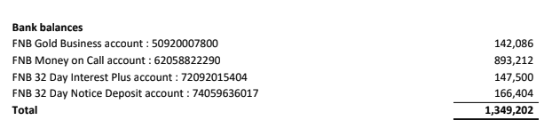

4). **Income statement**

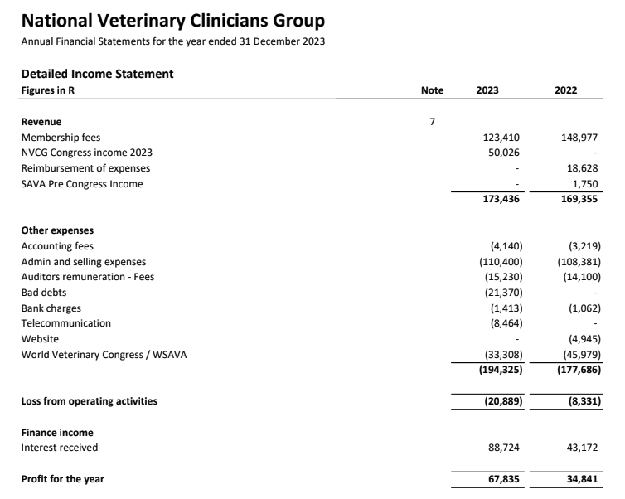

5). **Annual Financial Report:**

2023 Financials available for approval